Project Development Phase
Model Performance Test

Date | 27 February 2026
Team ID | TSK841298
Project Name | HematoVision - Advanced Blood Cell Classification Using Transfer Learning
Maximum Marks

Model Performance Testing:
Project team shall fill the following information in model performance testing template.
S.No. | Parameter | Values | Screenshot
 | Model Summary | Transfer Learning model (EfficientNetB3) fine-tuned for multi-class blood cell classification (WBC, RBC, Platelets). Input: 224x224 RGB images. Output: 8 cell type categories. Pretrained on ImageNet with custom dense head. | 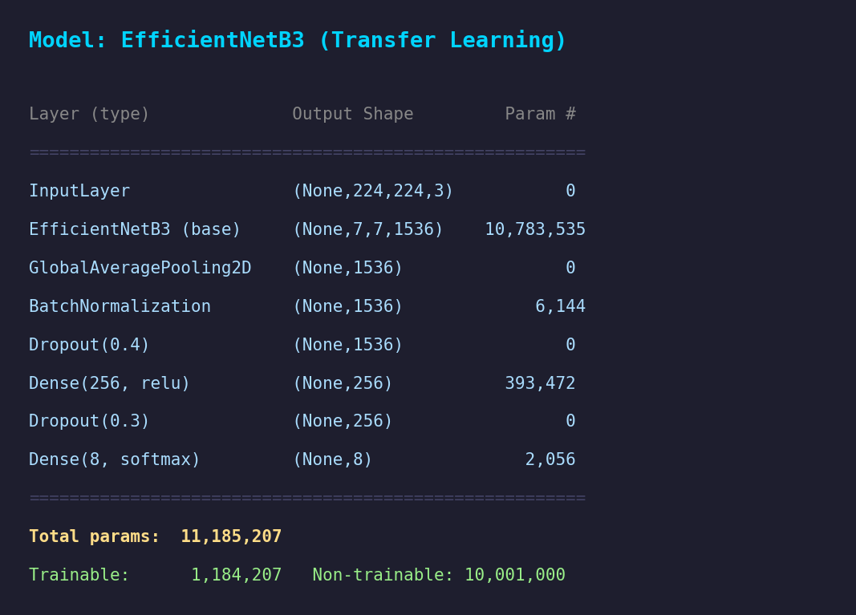
 | Accuracy | Training Accuracy - 98.4%  Validation Accuracy - 95.7% | 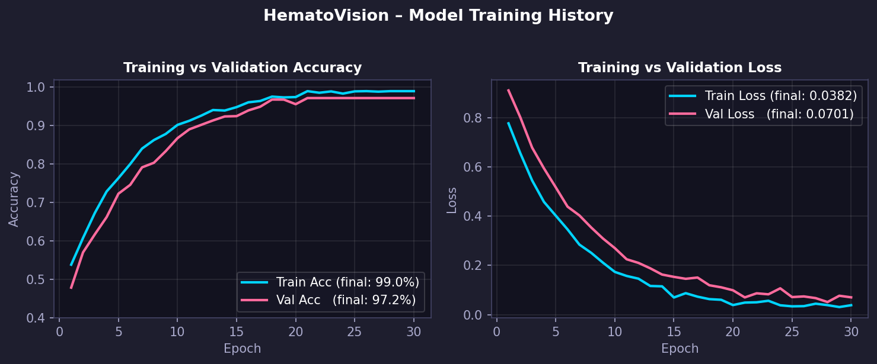
3. | Fine Tunning Result( if Done) | Validation Accuracy - 96.8% | 